FastQC to Annotation overview

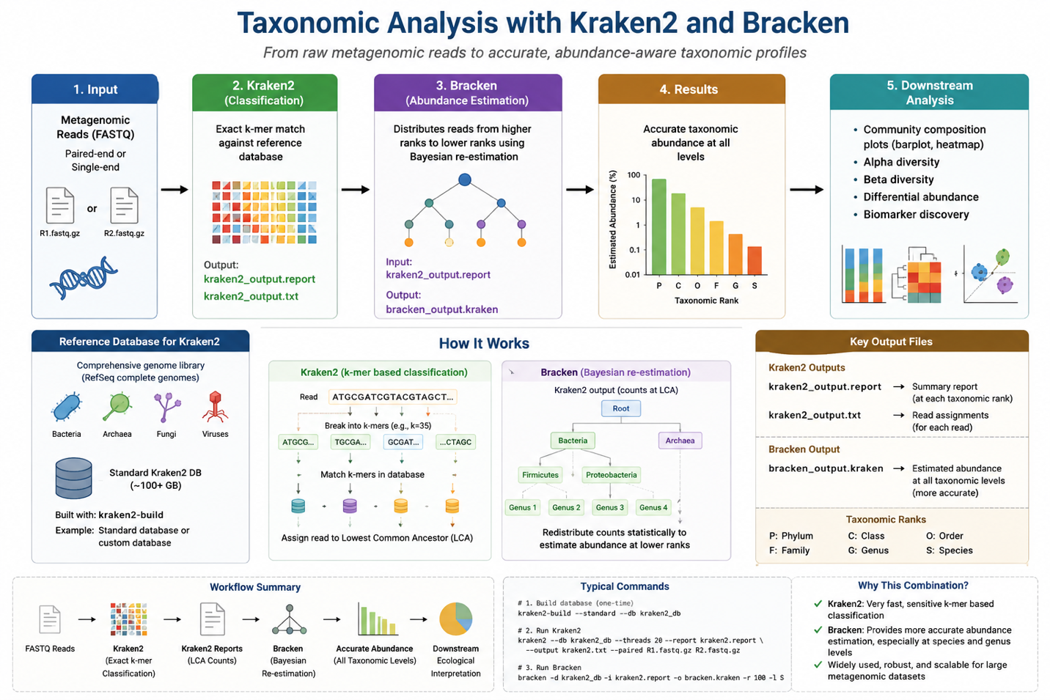

1st part: Taxonomy analysis by Kraken & bracken
# Organization
mkdir -p ~/Metagenomics_Analysis
cd ~/Metagenomics_Analysis
mkdir -p \
00_metadata \
01_raw_data \
02_fastqc_raw \
03_trimmed \
04_fastqc_trimmed \
05_multiqc \
06_host_removed \
07_taxonomy \
08_abundance \
09_function \
10_assembly \
11_genes \
12_MAGS \
13_AMR \
14_virulence \
15_MGE \
16_R_analysis \
17_figures \
18_results \
Scripts
# Check tree installation
tree
# Install tree if not installed
sudo apt install tree
# Create environment
conda create -n metagenomics \
-c conda-forge \
-c bioconda \
sra-tools \
fastqc \
fastp \
multiqc \
seqkit \
pigz \
-y
# Activate it
conda activate metagenomics
* Check version (minor)
fastqc --version
fastp --version
seqkit version
prefetch --version
fasterq-dump –version
# Download SRA file from NCBI
prefetch SRR33005305
# Split it into R1 and R2
fasterq-dump \
SRR33005305 \
--split-files \
--threads 8 \
--outdir 01_raw_data
# Compress them
pigz -p 8 01_raw_data/*.fastq
# Check the files
ls -lh 01_raw_data/
* Verify the fastq files (Optional)
seqkit stats 01_raw_data/*.fastq.gz
# Check the storage, RAM and CPU threads
df -h
free -h
nproc
1. Install Kraken inside Conda (Where can these reads be taxonomically classified)
conda install -c bioconda -c conda-forge kraken2
* Check the version (After checking it you should share the version information with AI)
kraken2 –version
2. Install Bracken inside Conda (How much of each taxon is likely represented in the sample)
conda install -c bioconda -c conda-forge bracken -y
* Update Kraken2 if require/AI suggest you to do
conda update -c bioconda -c conda-forge kraken2 -y
* Or create a new environment sometimes
conda create -n kraken_env \
-c conda-forge \
-c bioconda \
kraken2=2.1.6 \
bracken=3.0 \
-y
* & activate it
conda activate kraken_env
3. Kraken database
A) Create the location for database
~/Metagenomics_Analysis/databases/kraken2
B) Download database in that location
kraken2-build \
--standard \
--use-ftp \
--db ~/Metagenomics_Analysis/databases/kraken2 \
--threads 20
# Sometimes the database couldn’t download properly as it’s so large. So we have to download minikraken
wget -c \
"https://genome-idx.s3.amazonaws.com/kraken/k2_standard_08_GB_20260626.tar.gz"
# Download a checksum(MD5) file (will check the downloaded kraken databases are okay or not)
wget -c \
"https://genome-idx.s3.amazonaws.com/kraken/standard_08_GB_20260626/standard_08_GB.md5"
# Verify the downloaded kraken2 archive (will check either the downloaded kraken2 database doesn’t face any interruption)
md5sum -c <(grep 'k2_standard_08_GB_20260626.tar.gz' standard_08_GB.md5)
# Extract the kraken2 database file if everything is OK
tar -xzf k2_standard_08_GB_20260626.tar.gz
# Verify the extracted database
md5sum -c standard_08_GB.md5
# Test the kraken2 database by a simple initial run by kraken2
kraken2-inspect \
--db ~/Metagenomics_Analysis/databases/kraken2 \
| head -30
# Create a directory for kraken2 results
cd ~/Metagenomics_Analysis
mkdir -p 07_taxonomy/kraken2
# Run kraken2 (kraken2 will compare the reads from my fastq file with the database & if found any match it will tell me which taxonomy it is)
kraken2 \
--db ~/Metagenomics_Analysis/databases/kraken2 \
--paired \
--gzip-compressed \
--threads 20 \
--report 07_taxonomy/kraken2/SRR33005305.kraken2.report \
--output 07_taxonomy/kraken2/SRR33005305.kraken2.out \
01_raw_data/SRR33005305_1.fastq.gz \
01_raw_data/SRR33005305_2.fastq.gz
# Check the result
head -30 07_taxonomy/kraken2/SRR33005305.kraken2.report
4. Bracken database
* Install seqkit and check the actual read length again (Optional)
conda activate kraken_env
conda install -c bioconda -c conda-forge seqkit -y
seqkit stats \
01_raw_data/SRR33005305_1.fastq.gz \
01_raw_data/SRR33005305_2.fastq.gz
# Run bracken to generate species-level abundance
bracken \
-d ~/Metagenomics_Analysis/databases/kraken2 \
-i 07_taxonomy/kraken2/SRR33005305.kraken2.report \
-o 07_taxonomy/kraken2/SRR33005305.bracken.species.txt \
-r 200 \
-l S \
-t 10
# Check the result
head -20 07_taxonomy/kraken2/SRR33005305.bracken.species.txt
# Run bracken to generate genus-level abundance
bracken \
-d ~/Metagenomics_Analysis/databases/kraken2 \
-i 07_taxonomy/kraken2/SRR33005305.kraken2.report \
-o 07_taxonomy/kraken2/SRR33005305.bracken.genus.txt \
-r 200 \
-l G \
-t 10
# Check the result
head -20 07_taxonomy/kraken2/SRR33005305.bracken.genus.txt

2nd part: Taxonomy analysis by MetAPhlan
# HUMAnN (profile microbial gene families, metabolic pathways, and their abundances)
# Create an environment and download HUMAnN
conda create -n humann_env \
-c conda-forge \
-c bioconda \
--strict-channel-priority \
python=3.12 \
humann=3.9 \
-y
# Activate it
conda activate humann_env
# verify supporting program of humann
* metaphlan (identify organisms)
which metaphlan
metaphlan –version
* bowtie2 (gene search in nucleotide level)
which bowtie2
bowtie2 –version
* diamond (gene search in protein level)
which diamond
diamond version
# Before download these tool’s database we need to check that which database version’s will be compatible for these tools.
A) conda list | grep -E 'humann|metaphlan|bowtie2|diamond|python'
B) conda list | grep -E 'hdf5|h5py'
# Check metaphlan database location and installation option before run the database
echo $METAPHLAN_DB_DIR
metaphlan --help | grep -A3 -B3 "install"
5. Download metaphlan database
metaphlan –install
# Check the result
metaphlan –version
which metaphlan
which bowtie2
bowtie2 –version
* Sometimes problem appears. Ex- Conda shows a version of bowtie but the actual program file shows a different bowtie version. In that case we have force conda to reinstall the correct version (Optional)
conda install -c conda-forge -c bioconda --force-reinstall bowtie2=2.5.5
# Run MetAPhlan (similar tools like kraken & bracken)
metaphlan \
01_raw_data/SRR33005305_1.fastq.gz,01_raw_data/SRR33005305_2.fastq.gz \
--input_type fastq \
--nproc 20 \
--mapout 08_taxonomy/metaphlan/SRR33005305.mapout.bz2 \
-o 08_taxonomy/metaphlan/SRR33005305_metaphlan_profile.txt
# Check the result
ls -lh 08_taxonomy/metaphlan/
head -30 08_taxonomy/metaphlan/SRR33005305_metaphlan_profile.txt
# Extract species level metaphlan result
grep '|s__' \
08_taxonomy/metaphlan/SRR33005305_metaphlan_profile.txt

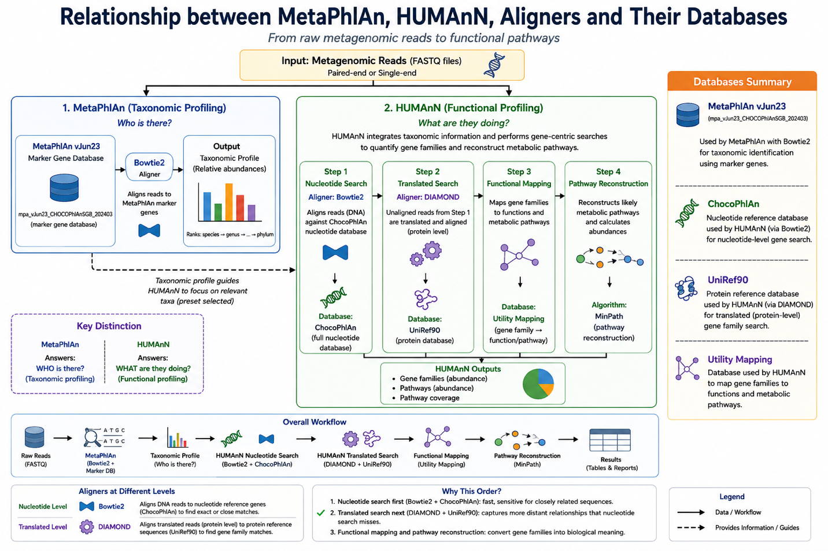
3rd part: HUMAnN functional profiling
* Check the configuration of HUMAnN and other databases
humann --version
which humann
diamond version
humann_config –print
# Before download the human database, check which database will support the installation
humann_databases –help
humann_databases –available
* Sometimes may need to check the free space of the ubuntu
6. Download HUMAnN database (Chocophlan, uniref, utility)
A) Install ChocoPhlAn (nucleotide-level search against microbial pangenomes)
mkdir -p ~/Metagenomics_Analysis/databases/humann/chocophlan
humann_databases \
--download chocophlan full \
~/Metagenomics_Analysis/databases/humann/chocophlan
B) Install UniRef (protein-level translated search with DIAMOND)
mkdir -p ~/Metagenomics_Analysis/databases/humann/uniref90
humann_databases \
--download uniref uniref90_diamond \
~/Metagenomics_Analysis/databases/humann/uniref90
C) Install Utility mapping (convert gene-family results into functional/pathway information)
mkdir -p ~/Metagenomics_Analysis/databases/humann/utility_mapping
humann_databases \
--download utility_mapping full \
~/Metagenomics_Analysis/databases/humann/utility_mapping
* Check the downloaded database
ls -lh ~/Metagenomics_Analysis/databases/humann/
# Run HUMAnN
A) Create directory for concatenate file
mkdir -p 01_raw_data/humann_input
B) Concatenate the both .fastq file
cat \
01_raw_data/SRR33005305_1.fastq.gz \
01_raw_data/SRR33005305_2.fastq.gz \
> 01_raw_data/humann_input/SRR33005305_combined.fastq.gz
C) Check the concatenate result
ls -lh 01_raw_data/SRR33005305_*.fastq.gz \
01_raw_data/humann_input/SRR33005305_combined.fastq.gz
D) Create directory for human run
mkdir -p 09_functional/human
* So when I am running HUMAnN (3.9) it causes some errors. Because when HUMAnN called Bowtie2 from MetAPhlan (4.2.6) & its database (JUN26), it shows mismatch. As HUMAnN (3.9) is compatible with MetAPhlan (4.1.1) & its database (JUN23). So, now we have to create a new environment with preferred MetAPhlan & its database.
# Create a new environment
conda create -n humann39_env \
-c conda-forge \
-c bioconda \
python=3.11 \
metaphlan=4.1.1 \
bowtie2=2.5.5 \
diamond=2.2.5 \
pip \
-y
# Activate the environment
conda activate humann39_env
# Check the result
python --version
metaphlan --version
bowtie2 --version
diamond –version
# Install HUMAnN separately
pip install humann==3.9
python -c "import humann; print(humann.__version__)"
# Create directory for metaphlan database
mkdir -p databases/metaphlan/vJun23
# Install metaphlan database
metaphlan \
--install \
--db_dir databases/metaphlan/vJun23 \
--index mpa_vJun23_CHOCOPhlAnSGB_202403
# Check the result
humann_config –print
bowtie2 --version | head -1
diamond version
metaphlan --help | grep -A3 -B3 "bowtie2db"
# Configure human databases (help human databases to findout the location of other three)
humann_config --help
A) humann_config --update database_folders nucleotide /home/turtle/Metagenomics_Analysis/databases/humann/chocophlan/chocophlan
B) humann_config --update database_folders protein /home/turtle/Metagenomics_Analysis/databases/humann/uniref90/uniref
C) humann_config --update database_folders utility_mapping /home/turtle/Metagenomics_Analysis/databases/humann/utility_mapping/utility_mapping
# verify all three
humann_config –print
# Run HUMAnN
humann \
-i 01_raw_data/humann_input/SRR33005305_combined.fastq.gz \
-o 09_functional/humann \
--threads 20 \
--search-mode uniref90 \
--output-basename SRR33005305 \
--metaphlan-options "--bowtie2db /home/turtle/Metagenomics_Analysis/databases/metaphlan/vJun23 --index mpa_vJun23_CHOCOPhlAnSGB_202403" \
-v
# Show the result
ls -lh 09_functional/humann/SRR33005305_*.tsv
# Analyze the result

